**OUTPUT**

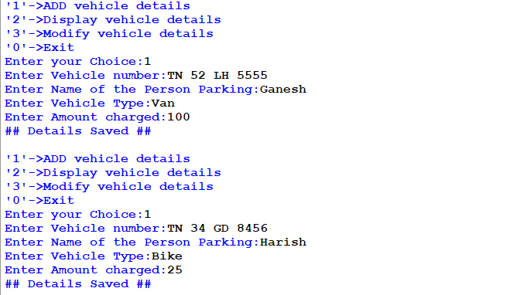

**MySQL Output:**

